INSTRUMENTAL ANALYSIS LABORATORY
DEVICES

- LC MS/MS
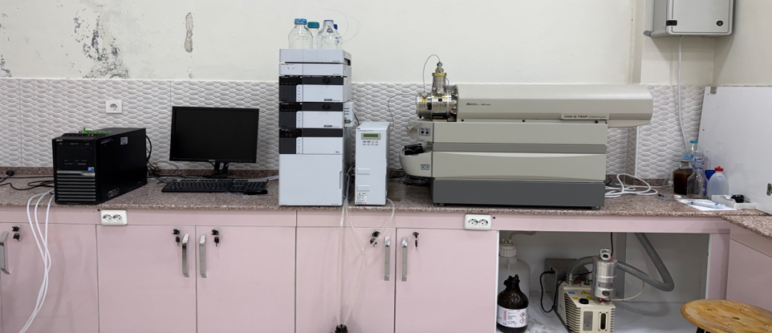
LC: Shimadzu liquid chromatographic system
Detector: AB Sciex mass spectrometer
LC MS/MS, also known as tandem mass spectrometry, is an advanced analysis instrument that measures the mass-to-charge ratio (m/z) of molecules in a sample with very high sensitivity and uses two sequential mass analysis stages to distinguish structural features of molecules.

The molecules in the sample are ionized with the Ion Source. Ions are separated based on their mass-to-charge ratios. The target molecule is selected and isolated for fragmentation. The selected ions are fragmented by colliding with inert gas (argon, nitrogen). The resulting fragments carry information about the molecule's structure. The fragmented ions are separated again and sent to the detector, creating a fragmentation spectrum. It detects the ion signals with high sensitivity, digitizes them, and transmits them to the software.

LC MS/MS systems are particularly used in applications requiring high accuracy even at very low levels, such as:
• Quantitative analysis (e.g., drug residues, pesticides, toxins)
• Metabolite identification
• Protein/peptide analysis
• Environmental and food safety testing
• Forensic and clinical analyses
Contact
Environmental Instrumental Lab Extension Number: 8420
Unit Managers | Extension Number | E-mail Adress
Lec. Mehmet ŞAHİN | 8420 | sahin@firat.edu.tr

2- HIGH PERFORMANCE LIQUID CHROMATOGRAPHY (HPLC)
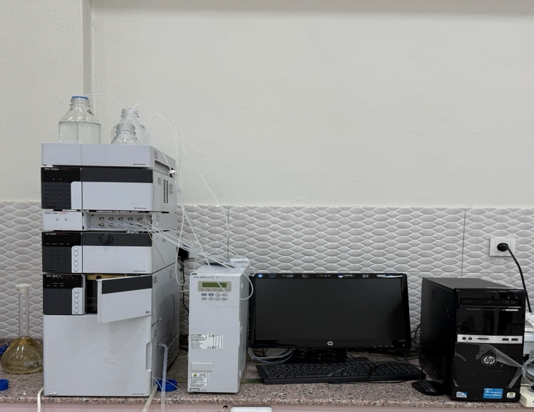
LC: Shimadzu Liquid Chromatographic System
Detector: PDA/DAD

HPLC (High Performance Liquid Chromatography) is a modern liquid chromatography system that separates, identifies, and quantitatively measures the components in a mixture using a high-pressure liquid flow. Shimadzu is a widely preferred manufacturer in the chemical, pharmaceutical, food, environmental, and biotechnology fields for its high-sensitivity, reliable, and reproducible analyses.

HPLC systems generally use a pump to deliver the mobile phase into the column at constant, high pressure. The pump system can operate in isocratic or gradient modes. Samples are injected using an automatic sampler, providing highly reproducible, precise microliter sampling. The column, located within the column oven, allows the components in the sample mixture to interact with the stationary phase within the column and are separated based on their retention times. The column is then sent to the detector for evaluation.

HPLC systems are used in a wide range of applications, including:
• Active pharmaceutical ingredient (API) and impurity analysis
• Food additives and contaminants
• Pesticide, toxin, and environmental analysis
• Determination of drug levels in biological samples
• Impurity profiling of chemical mixtures
• Polymer and aromatic compound analysis
Contact
Environmental Instrumental Lab Extension Number: 8420
Unit Managers | Extension Number | E-mail Adress
Lec. Mehmet ŞAHİN | 8420 | sahin@firat.edu.tr

  - İYON KROMATOGRAFİSİ (IC)
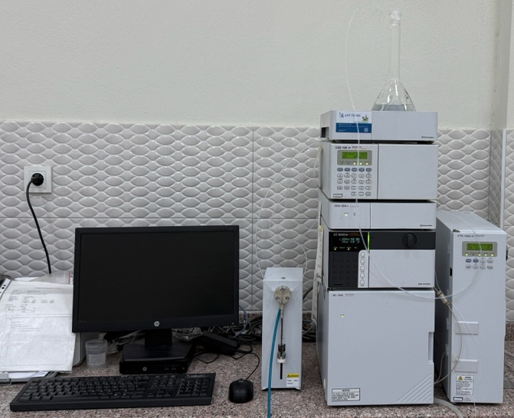
LC: Shimadzu Liquid Chromatographic System
Detector: Conductivity Detector
Shimadzu Ion Chromatography (IC) is a high-sensitivity chromatography system used to separate, identify, and quantify charged species such as anions and cations in aqueous samples.
IC systems generally use the following methods: A pump delivers the mobile phase to the column with high precision. Samples are injected from the automatic sampler, ensuring precise sampling with high reproducibility. The sample, passing through the ion exchange column within the column oven, is sent to a conductivity detector for evaluation.
IC systems are used in a wide range of applications, including:
• Drinking water and wastewater analysis
• Environmental monitoring
• Food and beverage analysis (e.g., determination of anions in drinking water)
• Pharmaceutical and pharmaceutical process control
• Ultrapure water analysis in the electronics industry
• Chemical process monitoring
Contact
Environmental Instrumental Lab Extension Number: 8420
Unit Managers | Extension Number | E-mail Adress
Lec. Mehmet ŞAHİN | 8420 | sahin@firat.edu.tr

4- ATOMIC ADSORPTION SPECTOROMETER (AAS)
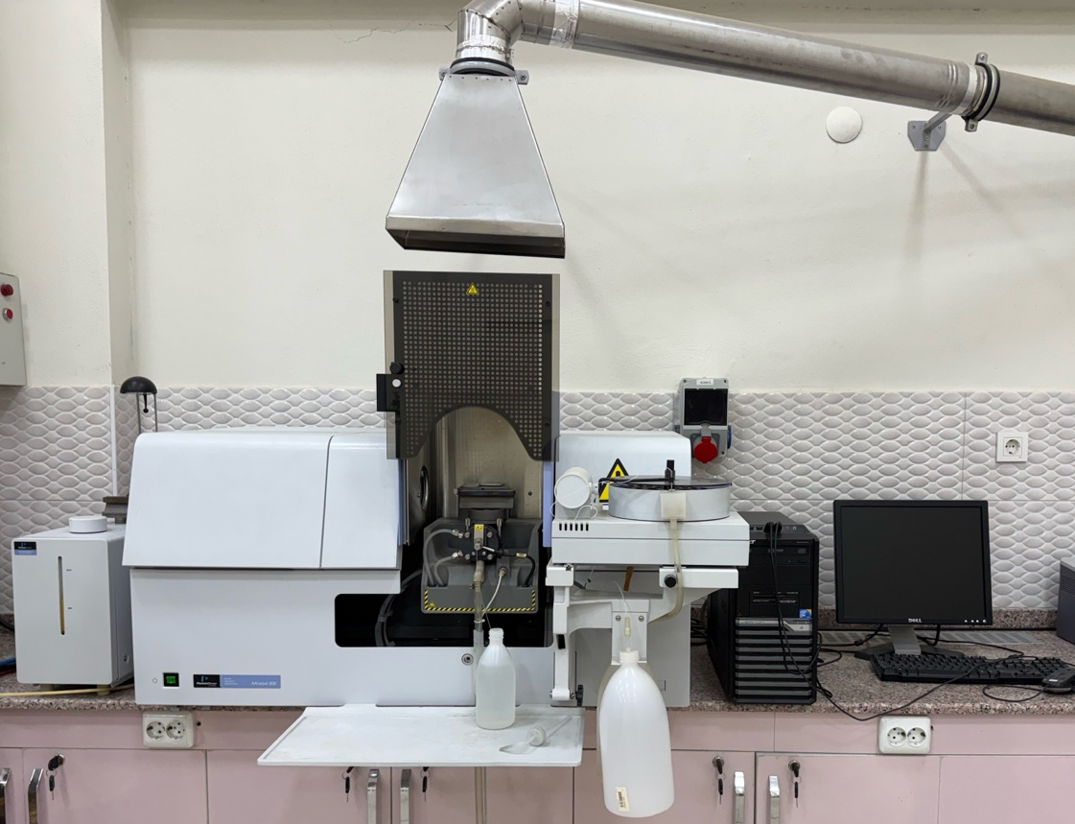
The PerkinElmer AAnalyst 800 is an advanced atomic absorption spectrometer that combines both Flame AAS (Flame AAS) and Graphite Furnace AAS (GFAA) modes in a single instrument, enabling the measurement of elements even at very low concentrations.
Elements in the sample are atomized (in a flame or graphite furnace). A hollow cathode lamp (HCL) installed in the instrument emits light specific to the element. The atoms in the sample absorb a portion of this light. The detector calculates the element's concentration based on the amount of absorption.
AAS is used in a wide range of applications, including:
• Drinking water and wastewater analysis
• Food and feed analysis (Pb, Cd, Fe, Zn, etc.)
• Pharmaceutical raw material impurity control
• Environmental analysis
• Metal, electroplating, and chemical process analysis
Contact
Environmental Instrumental Lab Extension Number: 8420
Unit Managers | Extension Number | E-mail Adress
Lec. Mehmet ŞAHİN | 8420 | sahin@firat.edu.tr

4- GAS CHROMATOGRAPHY (GC-TCD)
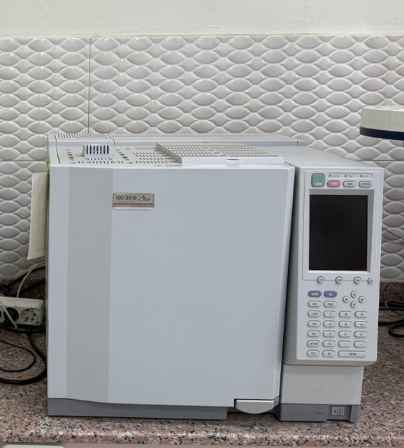
GC: Shimadzu Gas Chromatographic System
Detector: Thermal Conductivity Detector
Gas chromatography is a laboratory technique used for the separation and analysis of volatile compounds. The sample is vaporized and forced into a column with an inert carrier gas (usually helium, nitrogen, or hydrogen). The sample exiting the column is sent to a TCD detector. The TCD (Thermal Conductivity Detector) is a universal GC detector that operates by measuring the difference in thermal conductivity between the carrier gas and the compounds exiting the column. It can generate signals for all types of organic and inorganic compounds. This is why it is known as a "universal detector."
It is generally used for the analysis of CO₂, CO, NOx, SO₂, and inorganic gases.
GC-TCD
• Biogas composition (CH₄ / CO₂)
• Pure gas analysis
• Petrochemical gases
• Solvent mixtures
• Air / exhaust gas components.
GC-TCD is a versatile, easy-to-use gas chromatography system in which gases and volatiles are analyzed according to their thermal conductivity differences.
Contact
Environmental Instrumental Lab Extension Number: 8420
Unit Managers | Extension Number | E-mail Adress
Lec. Mehmet ŞAHİN | 8420 | sahin@firat.edu.tr
  - GAS CHROMATOGRAPHY (GC-FID)
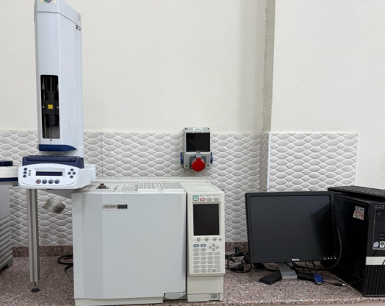
GC: Shimadzu Gas Chromatographic System
Detector: Flame Ionization Detector
Gas chromatography is a laboratory technique used for the separation and analysis of volatile compounds. The sample is vaporized and forced into a column with an inert carrier gas (usually helium, nitrogen, or hydrogen). The sample exiting the column is then collected by a highly sensitive GC detector, FID, which operates on the principle of organic substances burning in a hydrogen-air flame to form ions. Organic compounds exiting the column enter the flame, forming ions. The detector then measures this ion current to generate a chromatogram.
It is generally used for the analysis of hydrocarbons, alcohols, esters, ketones, solvents, and volatile organic compounds (VOCs).
The commonly used gases are:
• Carrier gas: He, H₂, or N₂
• H₂ gas: Flame fuel
• Air (zero-air): Flame oxidant
GC-FID;
• Petroleum products (gasoline, diesel, LPG)
• VOC analysis
• Aroma and odor components
• Solvent purity tests
• Pharmaceutical solvent residues
• Biodiesel, biofuel analysis
• Organic compounds that do not require GC-MS
are used in such areas.
Contact
Environmental Instrumental Lab Extension Number: 8420
Unit Managers | Extension Number | E-mail Adress
Lec. Mehmet ŞAHİN | 8420 | sahin@firat.edu.tr
  - GAS CHROMATOGRAPHY (GC-MS)
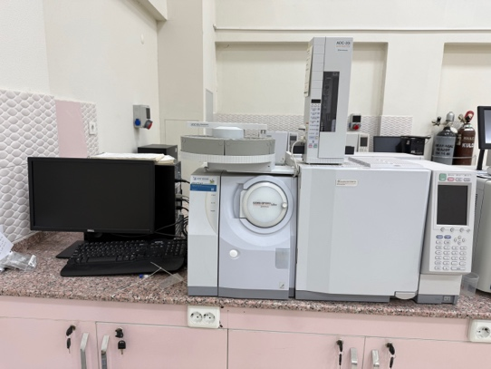
GC: Shimadzu Gas Chromatographic System
Detector: Mass Detector
GC–MS (Gas Chromatography–Mass Spectrometry) is one of the most powerful analytical systems for both the separation of complex mixtures and the identification of their components. It is one of the most powerful analytical instruments used for the separation (GC) of volatile and semi-volatile compounds and their identification (MS) with high accuracy. The sample is vaporized. Compounds are separated in a capillary column based on their volatility and polarity. Each column is then passed individually to the MS. The MS detector ionizes each compound and analyzes it based on its mass/charge ratio.

It is used in many areas. The main ones are:
Environment
• Pesticides
• PAHs
• VOCs
• BTEX
• PCBs
• Organochlorine compounds
Food
• Pesticide residues
• Flavor compounds
• Packaging migration
Forensic medicine
• Drug analysis
• Toxicology
Petrochemicals
• Light hydrocarbons
• Flavor profile
• Additives
Pharmaceuticals
• Residual solvents
• Purity testing
Contact
Environmental Instrumental Lab Extension Number: 8420
Unit Managers | Extension Number | E-mail Adress
Lec. Mehmet ŞAHİN | 8420 | sahin@firat.edu.tr

6- TOTAL ORGANIC CARBON (TOC) DEVICE

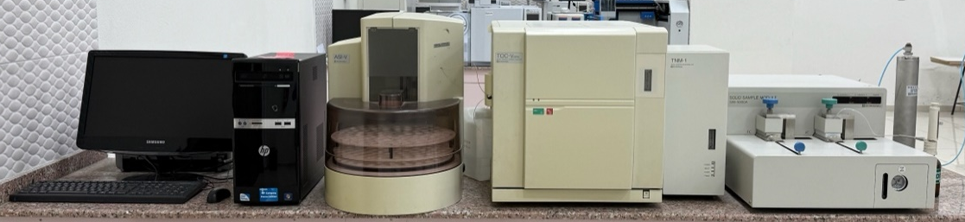
The TOC-V CPN is Shimadzu's analyzer for measuring Total Organic Carbon (TOC) in liquid samples. It measures the CO₂ formed by completely oxidizing the sample at 680°C using a catalytic combustion method with an NDIR detector. Integrated into this system, the SSM-5000A is a module that connects to Shimadzu TOC devices and allows for TOC (Total Organic Carbon) measurement in solid samples. In this device, the sample is completely combusted in an oxygen environment at approximately 900°C. The resulting CO₂ is measured with the NDIR detector in the TOC device. This allows TC, IC, and TOC values ​​to be calculated. It is commonly used in the analysis of wastewater, drinking water, the pharmaceutical industry, and process water.
TOC device;
• TC, IC, TOC, and NPOC analyses in liquid samples
• Soil
• Sludge and sediment
• Solid waste
• Food and compost
• Filters, resins, and polymers
Allows carbon analysis in solid samples.
Contact
Environmental Instrumental Lab Extension Number: 8420
Unit Managers | Extension Number | E-mail Adress
Lec. Mehmet ŞAHİN | 8420 | sahin@firat.edu.tr

